ASEN 2001

Lab 1: Computer Analysis of Structures – Fall 2018

Daniel Barth

Robert Redfern

Ruben Hinojosa Torres

Section 011

Due: September 28th, 2018

Problem 4-11 Solution

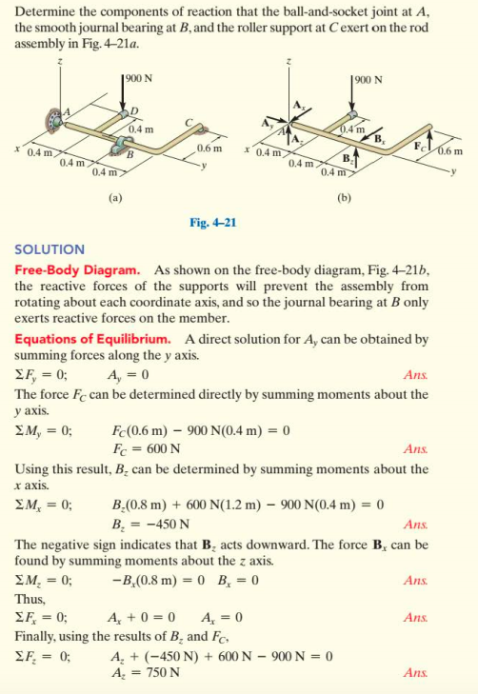

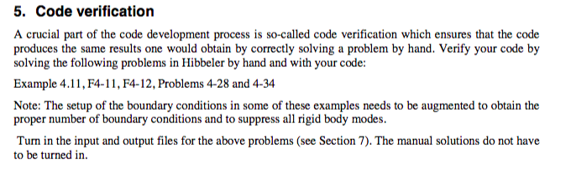

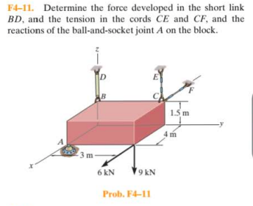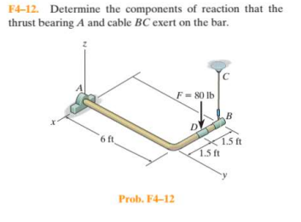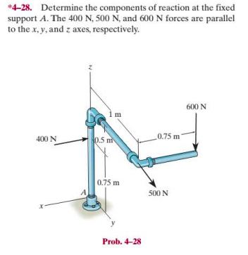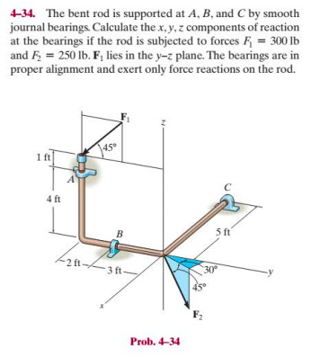

Theory Manual (1Page)

Describe the theory and procedure analyzing the reaction forces for a 3-D structure in static equilibrium. Clearly define the theoretical limitations of your code and discuss the assumptions your analysis procedure is based on. Cite references as applicable.

The foundation for analyzing reaction forces and moments for structures in 3-D equilibrium lie in six fundamental equations.

Developer / User Manual. (3 pages) Describe the structure of your code, the functionality of the routines you have developed, and outline the usage of your code including the content and format of the input and output files. Describe clearly how the user can run the verification examples.

The MATLAB source code should not be included in the report; neither within the body of the text nor as appendix.

Format: The report should be written in MS Word using 12pt New Times Roman and 1” page margins. Larger fonts can be used for headings. No other formatting requirements need to be met